

Capstone Project

DFD and class diagram of AI powered X-Ray Detection with Explainable AI

Internal Advisor:
Farooq Javed

Project Manager:

Project Team:

Muhammad Saad Razzaq

Mohad Imran(TL) – BSCS51F22S095
Muhammad HamzaTM) – BSCS51F22S052 Umer Aslam(TM) – BSCS51F22S084

Submission Date:
18 November, 2025

Project Manager’s Signature

Data Flow Diagram
The Data Flow Diagrams (DFDs) of the AI-Powered Real Estate Investment Platform illustrate how user inputs, property data, and AI models interact within the system.
They highlight the flow of information from users to various analytical modules such as valuation, ROI prediction, recommendations, and chatbot services, and finally back to the user in the form of insights and reports. The DFDs provide a clear view of how data moves across processes, data stores, and external entities.

DFD Level 0 - Context Diagram:
DFD Level 0, also called the Context Diagram, shows the system as a single high-level process and its interactions with external entities. It focuses on the overall input and output without detailing internal processes.

Description:
  - The system interacts with Clinicians / Doctors, who upload X-ray images and receive diagnostic reports.
  - External entities include Patient Database for storing records and AI Model Service for processing images.
  - The diagram highlights one major process, i.e., the AI-Powered X-Ray Detection System, which receives inputs, processes data, and produces outputs.
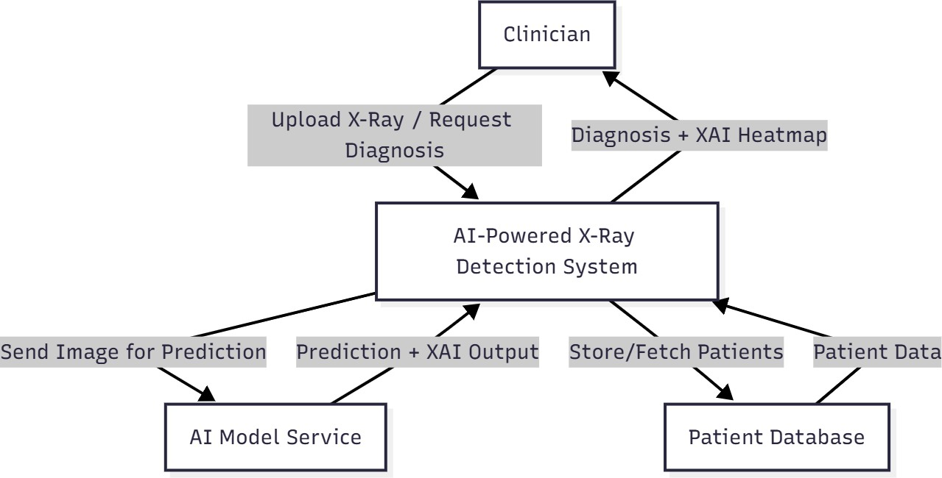

DFD Level 1 - Top-Level Processes:
DFD Level 1 decomposes the Level 0 process into main functional modules of the system.

Processes included:

- Image Upload: Receives chest X-ray images from users.
- Preprocessing: Performs data cleaning, normalization, and resizing to prepare images for model input.
- Disease Detection: Uses deep learning models (CNN, ResNet, DenseNet) to classify pneumonia and tuberculosis.
- Explainability (XAI): Generates visual explanations (Grad-CAM / LIME) highlighting regions influencing predictions.
- Report Generation & Storage: Compiles diagnostic reports, stores them in the database, and presents them to users.
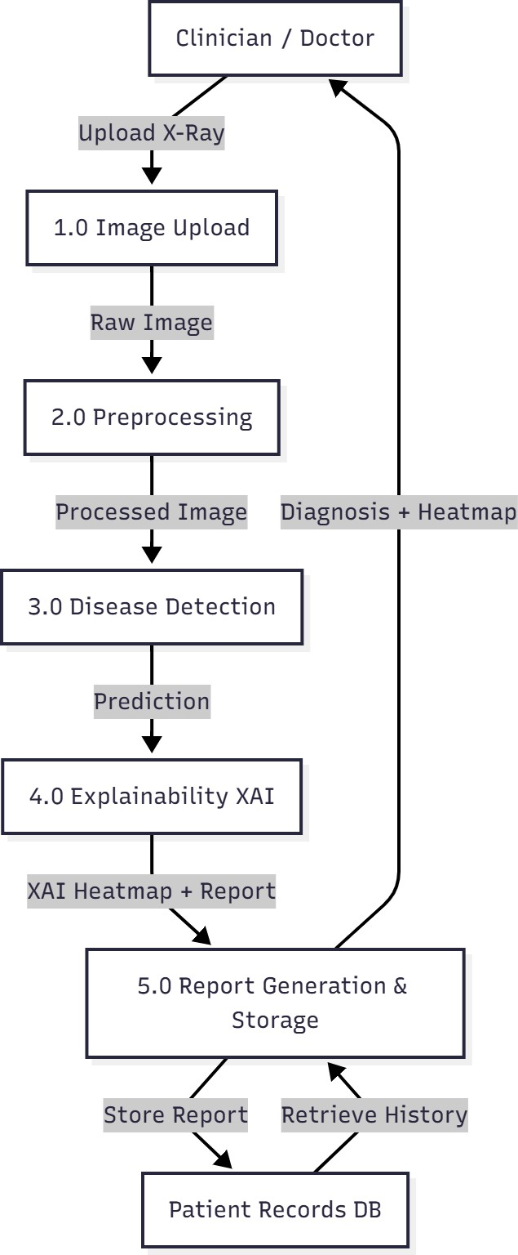

DFD Level 2 - Sub processes for Each Major Module:
DFD Level 2 further decomposes one of the Level 1 processes, typically the Disease Detection module.

Example decomposition:

  - Model Selection: Determines which AI model (CNN, ResNet, DenseNet) to use.
  - Model Inference: Runs the selected model on the preprocessed image to predict disease.
  - Confidence Calculation: Computes prediction confidence scores for transparency.
  - Result Packaging: Prepares outputs for Explainability and reporting modules.
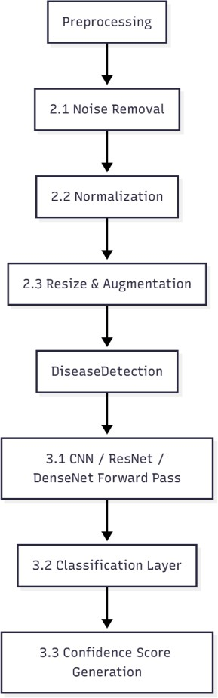

DFD Level 3 - Internal Logic of Key Processes:
DFD Level 3 provides the most detailed breakdown of specific processes, such as

Explainability or Report Generation. Example decomposition (Explainability):
  - Heatmap Generation: Uses Grad-CAM or LIME to highlight affected regions in X-ray.
  - Overlay Creation: Combines heatmap with original X-ray for visual clarity.
  - Report Integration: Inserts heatmap and AI predictions into the diagnostic report.
  - User Output: Sends the final report and visualization to the clinician.

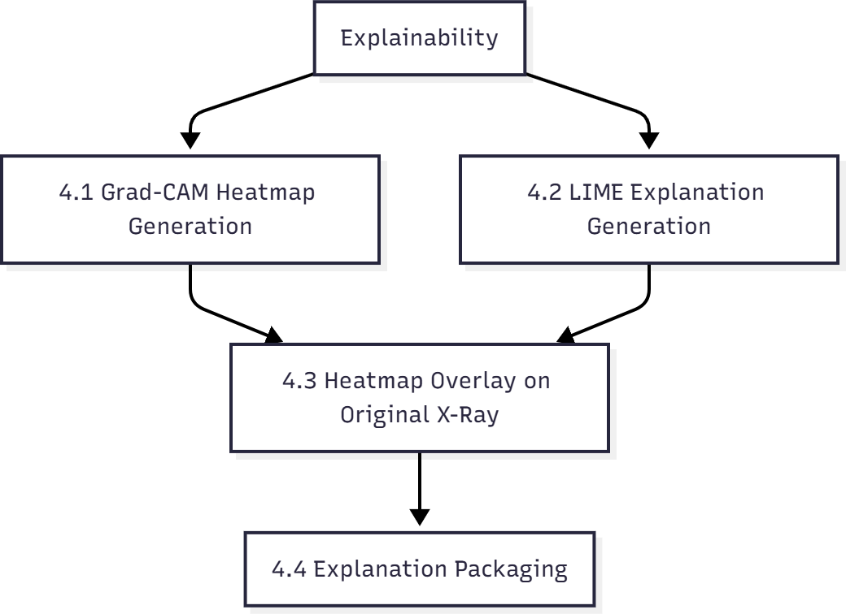

Class Diagram
A Class Diagram is part of UML (Unified Modeling Language) used to show the structure of the system, including classes, attributes, methods, and relationships between classes.

Classes in the AI-Powered X-Ray Detection System:

  - User: Represents clinicians, technicians, and admins with attributes like userID, role, and login credentials.
  - Patient: Contains patientID, name, age, medicalHistory.
  - XRayImage: Stores image file information, metadata, and upload details.
  - DiseaseDetectionModel: Represents AI models with attributes like modelType, accuracy, and methods such as predict().
  - Explainability: Handles Grad-CAM or LIME visualization methods.
  - Report: Stores diagnostic results, heatmaps, and confidence scores.
  - Database: Represents interaction with patient and report storage.
